Week 6 Practical 6
Objectives:
To identify the functions of MS excel.
- Create the following excel sheet and complete it using following description.
  - If total expense are grated than the amount budget, you may want to display a warning. If not you would display the amount of money left in the budget. Write the correct formula to express the given conditions.
- Dehiwala Zoo gives a number of different discounts based on the age of the visitors. Senior Citizens(over 65 years) pay only Rs.25.00 per tickets. Children from 15th to 5 years old are Rs.15.00 and children under 5 are free. All others are charged Rs. 50.00.

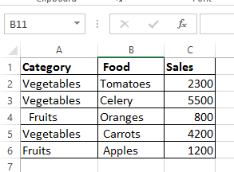
  - Find the Sum of the sales of all foods in the "Fruits" category.
  - Find the Sum of the sales of all foods in the "Vegetables" category.
- Create the following table in excel sheet
Name | Number
Apples | 32
Orange | 54
Peaches | 75
Apples | 86
Apples | 45
Orange | 52
Peaches
Apples | 66

  - Count the number of cell with “Apples” in the first column of the table.
  - Count the number of cells with a value greater than 55 in the second column.
  - Count the number of empty cells in the range.

  - Calculate the average basic salary of employee who earn more than 50,000 basic salary.
  - Calculate the average basic salary of employee who earn less than 50,000 basic salary.
  - Calculate the average net salary of employee who earn more than 50 000 basic salary and more than 60000 net salary.
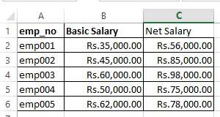

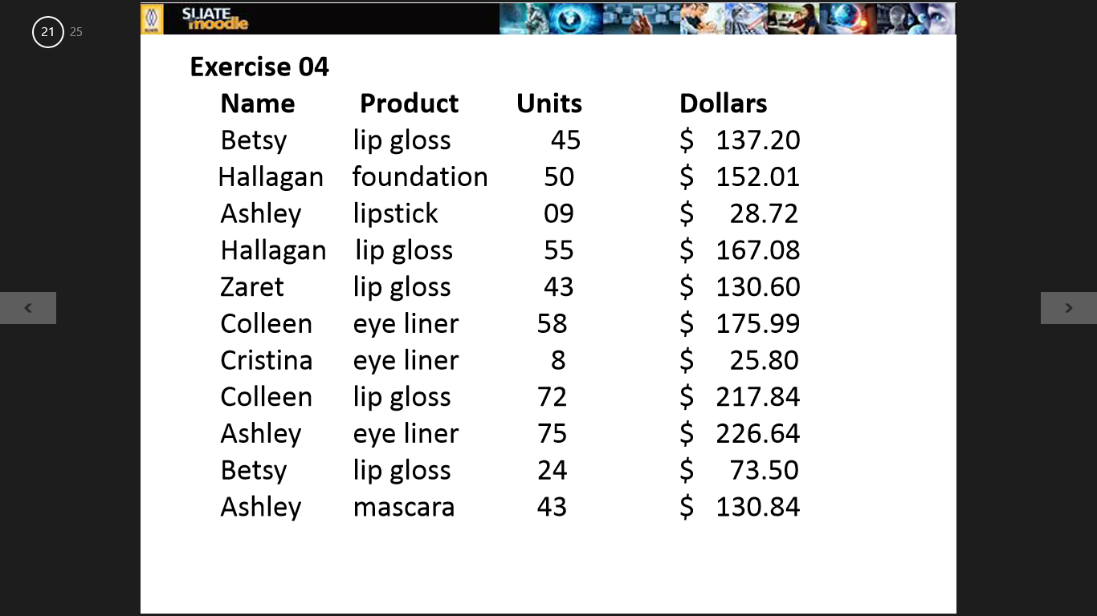

- Calculate the total of lip gloss sales done by Besty.
- Among the transactions involving at least 50 units, what is the total sales of eye liners?

- Create following table
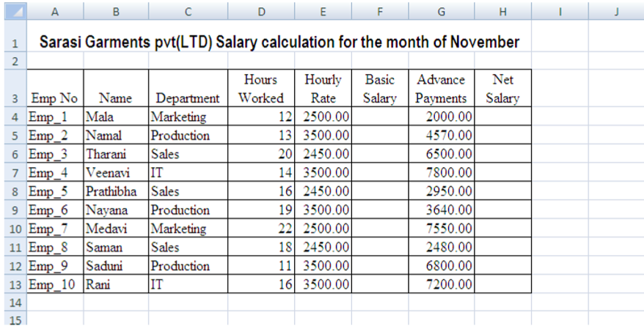
  - Calculate Basic Salary for Mala in cell F4 (hint: basic salary= hours worked x hourly rate)
  - Calculate the Basic Salary for others.
  - Write a formula for the cell H8, to calculate the “Net Salary” for Prathibha. And complete answers in other places as well.
  - Apply suitable formatting style to the table
  - Name the excel function to calculate the number of employees in the work sheet and apply that function in to cell A18
  - Name the tool you should used to display the heading across the cell range A1:H1?
  - Apply currency format
  - Name the excel function to obtain the number of employees who paid more than 35000.00 as their basic salary. Apply it in cell A22
  - Create column chart using Emp_no and Basic Salary.

